8D7N KUNMING DALI LIJIANG APR-JUN

Group size: 10-25pax
Period: April- June 2020 (8D7N Kunming-Dali- Lijiang)
Date | City | Schedule |  | Meal
D1 | Kunming- Shilin | Arrival Kunming, Meet our Tour guide and transfer to Check in hotel.  ãLocal 5* Shilin Days Tongce hotel or similar (Vienna royal) | AIR | D
D2 | Shilin- Jiuxiang- Kunming | Visit Shilin (Stone forest include buggy service),  Jiuxiang Karst Cave (inckude cable car+ cruise)  ãLocal 5* Kunming Xin Sheng Da Hong Sheng International hotel or similar  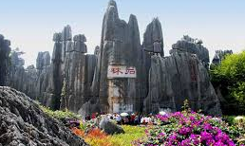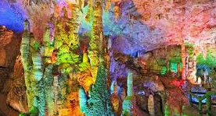 | v | BLD
D3 | Kunming- Dali | By bus to Dali 4.5hours, Visit Dali ancient town (exclude buggy) + Foreigner street  ã4* Dali San Ta Yuan hotel or similar  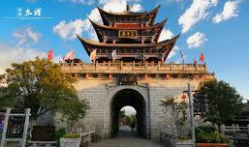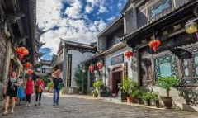 | v | BLD
D4 | Dali- Lijiang | Visit Xizhou White minority village+ Three course tea performance, Chongsheng Three pagodas temple (Outlook), Huayu Flower field, Erhai park. By bus to Lijiang, Visit Lijiang ancient city, Square street, Black Dragon lake...  ãLocal 5* Lijiang Doof Resort hotel or similar  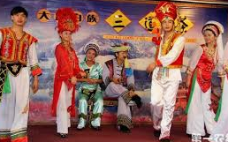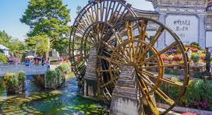 | v | BLD
D5 | Lijiang | Visit Jade Snow Mountain- Yunshanping (include cable car), Dry sea, Jade water village, Impression Lijiang show.  ãLocal 5* Lijiang Doof Resort hotel or similar  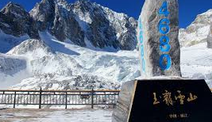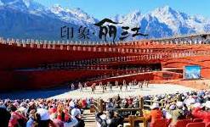 | v | BLD
D6 | Lijiang- Chuxiong | Visit Shuhe ancient town, Futa Park, Yi minority village.  ãLocal 5* Yun Hua hotel or similar | v | BLD
D7 | Chuxiong- Kunming | By bus to Kunming, Visit Golden horse memorial Arch, Nanping street, Green lake, Yuantong temple.  ãLocal 5* Kunming Xin Sheng Da Hong Sheng International hotel or similar  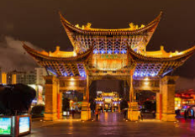 | v | BLD
D8 | Kunming | Visit Xishan dragon gate+ cable car+ buggy+ shuttle bus, transfer out.  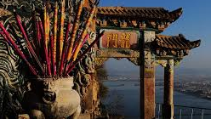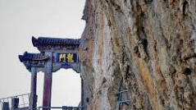 | v | BL

Special meal:
- Noodle over bridge
- Xizhou minority cuisine
- Yunnan’s Specialty

Tour Fare (use 17seater bus) : Usd512 RMB 3480/pax (10+0FOC) Single supplement.: Usd144 RMB980
Tour Fare (use 35seater bus) : Usd548 RMB 3730/pax (10+1FOC)
Tour Fare (use 35seater bus) : Usd463 RMB 3150/pax (15+1FOC)

Tour Fare (use 35seater bus) : Usd426 RMB 2900/pax (20+1FOC)
Tour Fare (use 47seater bus) : Usd423 RMB 2880/pax (25+1FOC)
Tour Fare (use 47seater bus) : Usd409 RMB 2780/pax (30+2FOC)

Remarks:
1) Include meal, Mandarin/English guide (every city one local guide), Entrance ticket, hotel (twin sharing)
2) Exclude Tips- Usd 3/pax/day， Optional tour, air ticket, bell boy
3) Compulsory Shopping: NO
4) Meal budget: RMB 40/pax/meal
5) Child with bed: 100% Child no bed: 75% (Child no bed exclude hotel breakfast)
6) FOC based on twin sharing
7) Free one mineral water per pax per day 350ml
8) Optional tour: Yunnan impression performance show RMB300/pax (Tour leader commision RMB 20/pax)
9) Tour leader please bring tour leader lisence, otherwise entrance ticket pay by own.

Rachel (27/11/2019)

